a VERY, VERY BASIC Survey of:
Methods of wiring up electronic components on a "Board"

Hand Wiring
Hand wiring means that you are placing individual components onto some sort of "board" and connecting them with individual wires or board paths to form a circuit. The component leads and connecting wires are usually, but not always, soldered in place. We won't be discussing automatic placing of components or automated soldering processes here.

Here is a list of available "boards" that can support electronic circuits :
Fahnestock Clips and real Wooden bread-slicing boards
This is the original "breadboard"! Back in the 1930's to the 1950's or 1960's we would screw spring-loaded clips called "Fahnestock Clips" to a 1" thick wooden board and build the circuit upon it. Small coil springs were also used as inter-connection points.
Here's a signal generator that I made in the late '60's using the fahnestock clips:
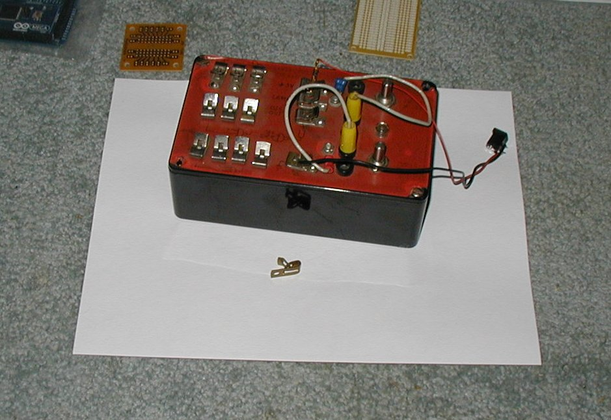
The "original" breadboard:
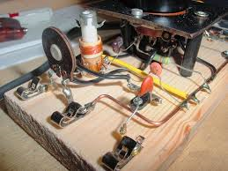

Here, below, is a complete breadboarding system, one that uses little vertically mounted coil springs for connnection points to the many on-board sensors. There is a small multi connector solderless breadboard in the center of the panel. The "perma-proto" boards mentioned later in this article emulate this solderless breadboard, making it make your project permanent.
Mounted on the breadboard are two small thermocouple amplifier "break out boards".
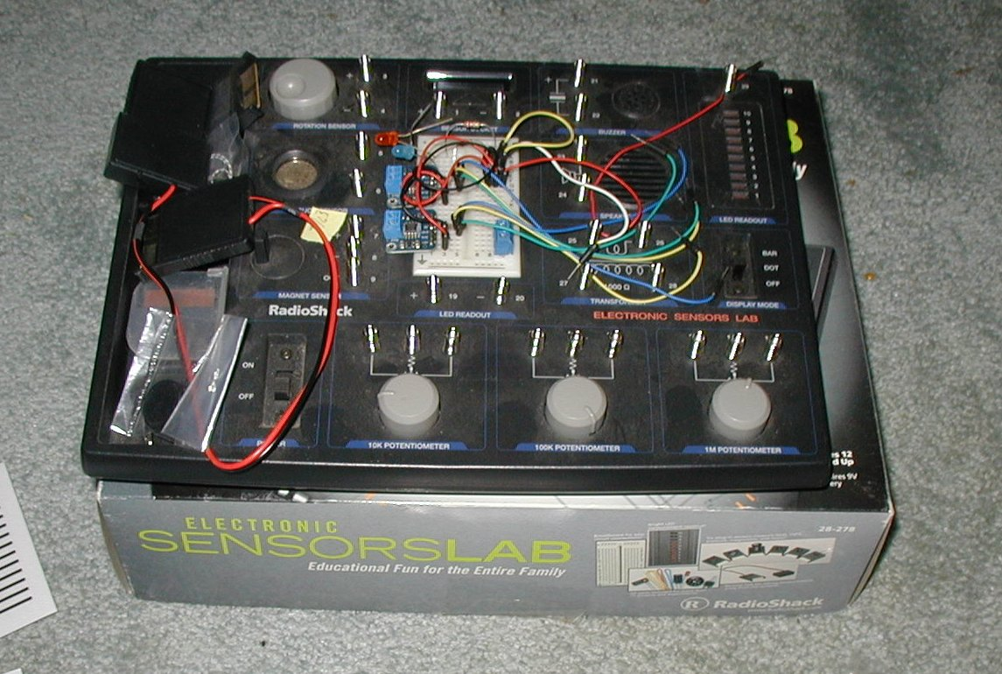

Solderless Breadboard
A solderless Breadboard is a (usually) plastic board with spring loaded female sockets below the surface. These connections accept only one wire or component lead at a time, so under the surface of the board, several of these connections or "tie points" are connected to each other. This allows chaining together of components to produce a complete circuit.
Quite often these boards will have separate power and ground busses.
Perf (Perforated) board/IC spacing Perf board (no solderable "Pads")
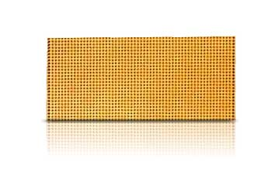
These boards have no copper on them and have no solderable pads. Just a lot of holes, on a specific spacing, often 0.1 inch apart in both the X and Y axes.
They make it easy to support components, but soldering is required if one is to make good electrical connections between components and connecting wires. These (usually) thin phenolic boards are an inexpensive approach to producing one-off circuits.
Plated hole board
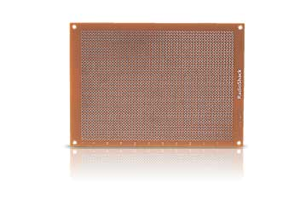
This is a basic "perf" board, but it has plated holes so you can solder components and connecting wires in place. However, with this style of board, none of the plated holes are connected to any other holes. So, in order to make connections, on must poke at least two wires into one hole )or use excess lead wire to connect adjacent parts, to build up a circuit.
Multi purpose/universal component pc board
These boards are similar to the basic plated hole board, but they have rows of pads that ARE connected together. This makes wiring a lot easier, since only one wire or component lead needs to be inserted in each hole.
Here below you see multipurpose boards, IC spacing boards and a "permaproto" type of board:
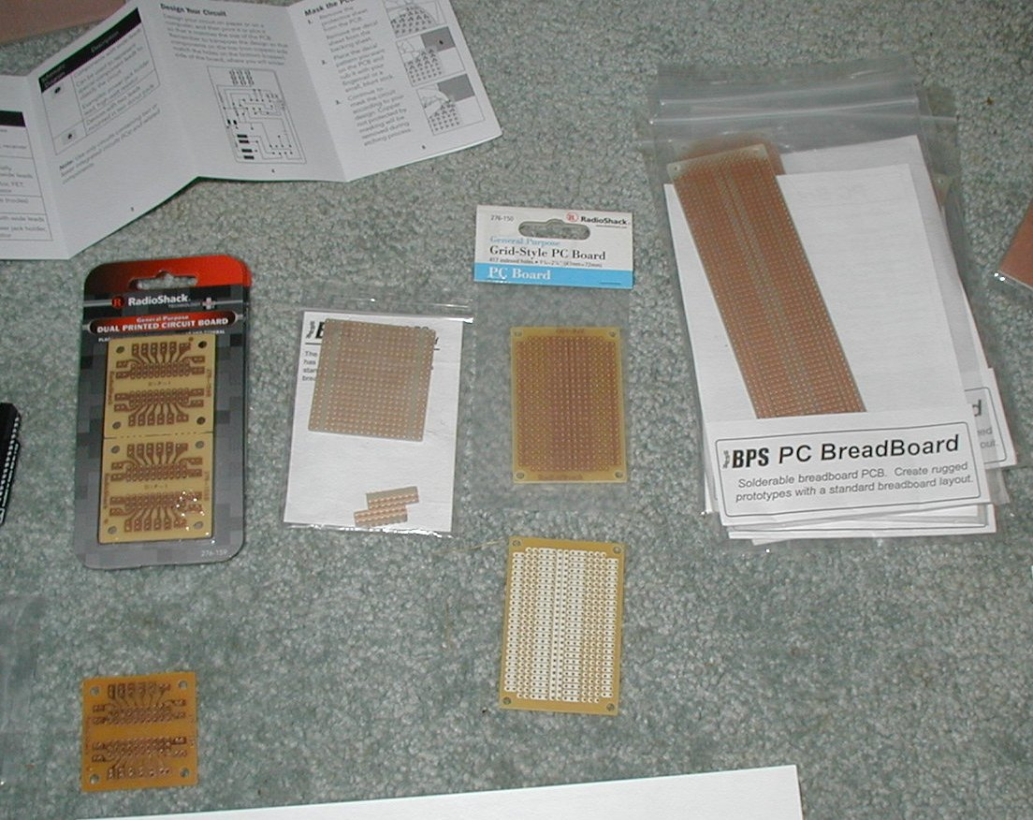

IC spacing PC board
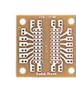
Very similar to the Multi purpose board, but these specialized boards have hole layouts that exactly fit certain integrated circuits. They come in a wide variety, but often are designed to hold one 14 pin DIP IC. These boards usually have pads interconnected to make wiring to the IC easy. Those pad areas are often called the "prototyping" area.

Schmartboard (Radio Shack)
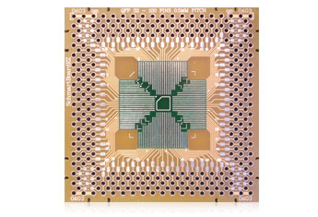
A special kind of "IC spacing PC Board", designed to make it easy to solder surface mount IC's in place. I guess their specialty is a "slide to solder" technique, needed because many surface mount chips have very small pin spacings.

Perma-Proto boards (Adafruit), "Solderable" Breadboard
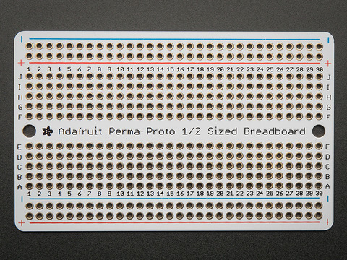
Another special kind of "Multi purpose/universal component pc board". This style of board exactly mimics the layout of popular "solderless breadboards" and comes in as many sizes as do the solderless breadboards themselves. Their purpose is to allow a person who has built a circuit on a solderless breadboard to move all components and wiring directly from the solderless breadboard to the Perma-Proto board, soldering everything in place.

Breakout Boards
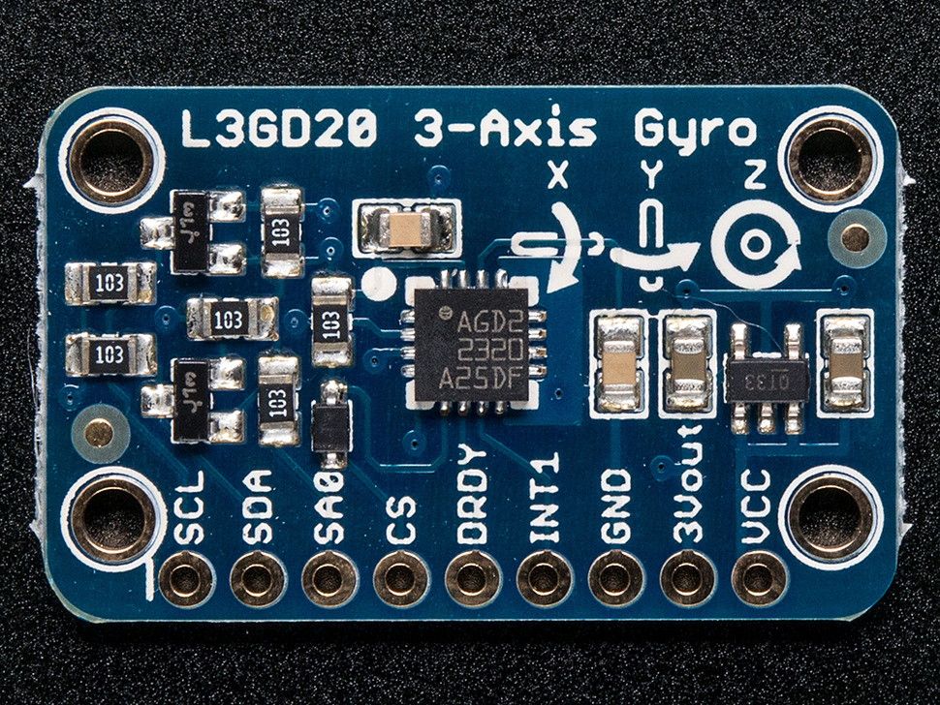
These are a special form of the "IC spacing PC board". They are usually designed to add header pin "legs" to a specific integrated circuit. These boards often have several components added that enhance that IC for a specific application.
Arduino-type shields
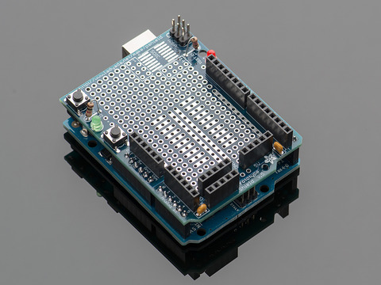
These boards are designed with all needed headers to plug right into (on top of) a particular microcontroller such as the Arduino UNO, etc.. They sometimes have a few components added that extend functions of the microcontroller for easy reach since the "shield" covers up the microcontroller itself. Shields almost always have useful prototyping areas which makes them useful like the "Multi purpose/universal component pc board" discussed above.
The picture below shows an Arduino ATMega2560 and a prototyping shield above it.
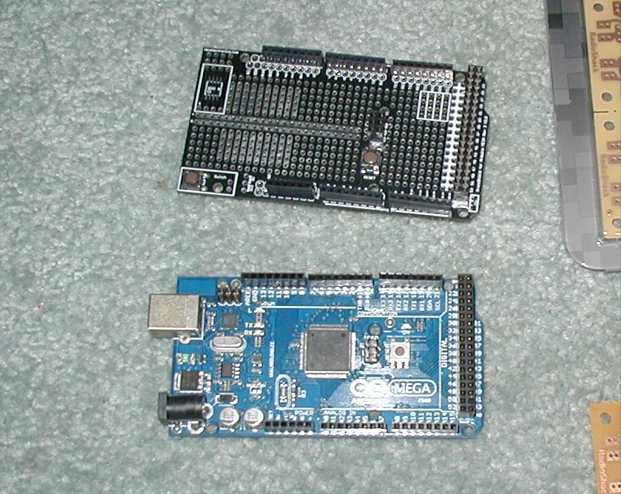

Methods for producing PC Boards
Sooner or later you must make a drawing of the circuit you wish to produce.
One approach is to draw up a wiring diagram which includes all the required components, the connections between all the components and any interfacing between this circuit and any others needed to complete a system. Usually, one draws a schematic diagram of the circuit first. This schematic diagram is usually designed to show circuit flow from left to right and from top to bottom and is technically accurate and easy to follow for a person with an electronic background, you.
But the schematic diagram probably isn't laid out the way you would lay out components and wiring on a "board". So you need to produce a point to point wiring diagram of the circuit that allows for placement of components and also for the wiring needed to connect them. Your schematic diagram can have wires jumping over each other but you can't do that with a single sided PC Board, so sometimes many iterations are needed to solve connection problems. This is one of many issues you confront in circuit layout and design.

So, here below, are a few of the possibilities for turning a circuit idea into a PC Board:
-------------------------------------------------------------------------------------------------------------------------

Converting the circuit schematic to PC Board Layout
Hand drawing the circuit
-As mentioned above, you can simply draw the circuit schematic diagram on a piece of paper. Use a pencil, so it's easy to make changes.
- Once you have an accurate representation of the circuit schematic diagram, you begin drawing a point to point wiring layout. Usually, one has all the actual components on hand at this time. You might start by simply laying out the components right onto a full size drawing of the board-to-be, to see where they need to fit. This will also help you discover what size of board you will need. Or, if you have constraint on space availability, how to fit the circuit onto the space available.
-Once components are initially positioned, you begin to attempt to connect all the components, following the electrical paths on schematic diagram. This can take a lot of time, depending on the complexity of the design and the density of components. Jumper wires may need to be added when circuit lines need to cross, etc..
-The completed wiring layout needs to have all component leads accurately placed so solder pads can be located. If using perf board, this accuracy is still important, since you will want the component leads to fit through existing perf board holes.
Using CAD software to draw your circuit and to design you PC Board
There are many software packages available for automating this process. Some are free, but most of them cost money, sometimes at lot of it.
Cadsoft Eagle Cad is an example of this kind of software. There is a limited feature free version, but the full featured version costs anywhere from $69 to $3800 at this writing.
This software allows you to build the schematic diagram on the monitor. You choose components from a long list of library items, place them on the "board" and then connect them, using the tools in the package.
Once you have designed you schematic, the software can check for obvious wiring errors and report them to you for your action.
When you are satisfied that the schematic diagram is just what you want, you push a few buttons and the program presents you with a copper path layout for your PC Board and much more. You can choose to accept it as it is or you can make changes as you need them.
At that point you can print a paper copy of your PC Board layout for use in etching a board, or you can convert the Eagle code for the board to the exact code needed by a company that makes PC Boards for a living. The code files can be electronically transmitted, so you don't even need to leave home to get your PC Boards made.

Here is a screenshot of an Eaglecad PC board layout, in the lower picture. Above it you see a couple of laser printed images ready to be ironed onto a piece of copper clad material before etching. To the left in the upper picture, there is a PC board made with that process.
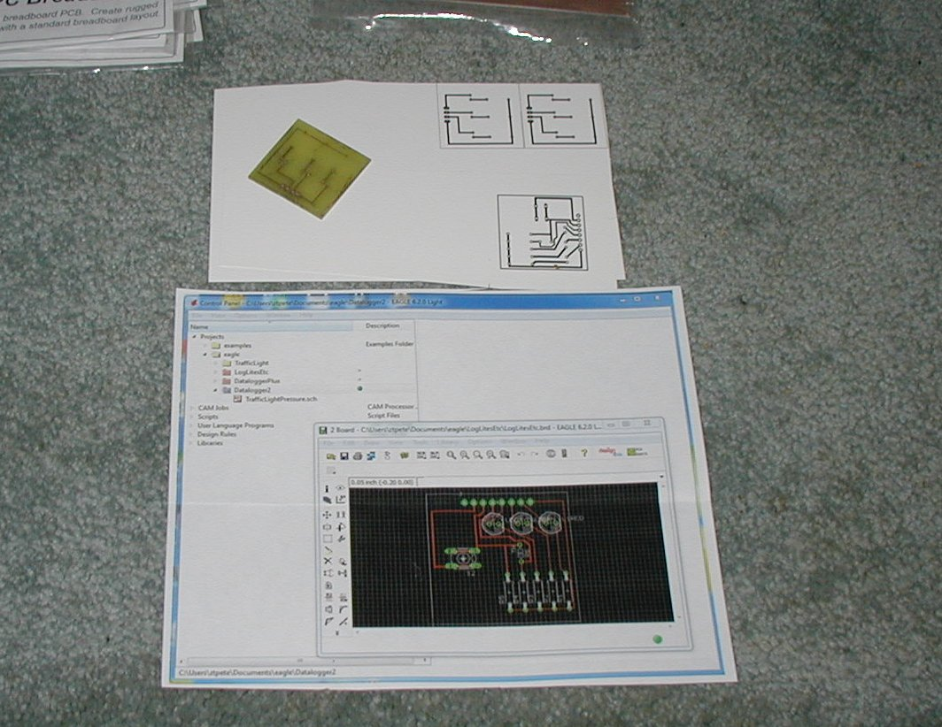

Now that you have a basic knowledge of turning a circuit idea into the wiring layout for a PC Board, let's look at a few of the many methods that are used at the hobbyist level for producing the ready-to PC Board that you originally needed:

-drill,
-stuff with components,
-solder.

------------------------------------------------------------------------------
Making a through-hole PC Board using the Ferric Chloride etching process
These processes are used with copper clad phenolic or fiberglass based boards. The idea here is to:
1. cover the copper in the areas where circuit paths are desired.
2. Chemically etch away the copper away in all areas except where circuit paths are wanted.
(You may want to leave copper non-circuit areas called "ground planes")
3. Drill holes in the completed board where components or wires will be needed.

Home-grown methods to protect the copper for being etched:
-Fingernail polish
-Sharpie, certain kinds of permanent markers
-Laser Printer/Iron for transfer
- Direct Taping-off of the copper clad board
Here below is a kit of materials used in this process. You apply the individual black "lines" and pads in the exact layout you need, right onto the copper clad substrate. The etchant does not penetrate the taped on material.
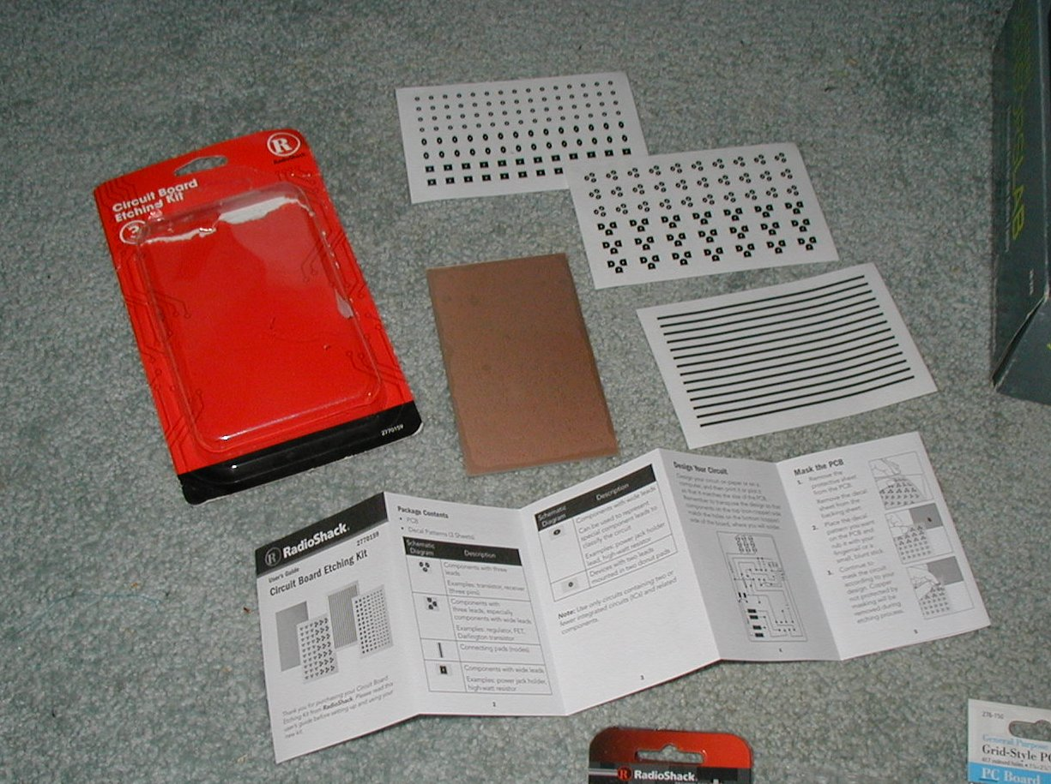

Home-grown method to place conductive material on a blank nonconductive board:
-Circuit Writer Pen

Commercial or advanced hobbyist methods:
-Taping up PC board masters
-Photo resist methods/Florescent exposure
-Sending away Eagle Cad (or other) files for commercial PC Board production

