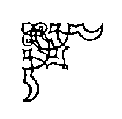
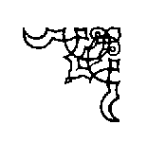
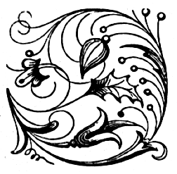
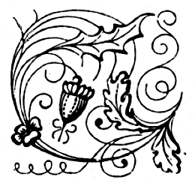
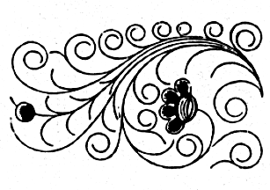
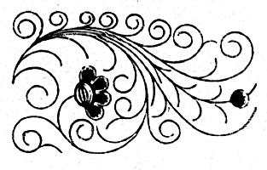
The Badger Blacksmiths
A Wisconsin Guild and ABANA Affiliate
“ We Can Forge Anything But A Check”

Volume 15, Issue 4, Newsletter Date 4/6/2016

Officers and Board
Jared Riesenweber President 715.983.5637 tudweber@hotmail.com
Dion Grethen Vice-President 715.651.3398 diongrethen@gmail.com
John Grump Secretary/Editor 715.835.0894 johngrump@att.net
Brad Hegge Treasurer 715.983.2131 heggeco@triwest.net
Ray Murray Board Member / 715.235.4882 rlmurray@pressenter.com
Director at large
Chuck Lindvig Librarian 715.832.3806 lindvig@charter.net

President’s Notes
President’s Notes April, 2016
A lot of people turned out for the March meeting at Brad's. We saw some new faces, gained new members and several visitors showed up to see what we do. I enjoyed spending more time forging and saw a lot of smiths working on a whole range of projects. I think we had more forges going and anvils ringing at the same time than most any meeting I can remember.
We will soon be holding the election of board members. I have been in the position of president long enough. I'm sure there are others who could handle it better. We need to see more members willing to step up. Please give some thought to taking on a position yourself, or encouraging someone you would like to see elected.

Jared Riesenweber
President
NOTICE

THE THEME FOR THIS MONTH’S MEETING WILL BE FORGING A HARDY-STYLE BENDING FORK. THE BENDING FORK IS A VERSATILE TOOL USED FOR BENDING AND FORMING MANY SHAPES INCLUDING SCROLLS, BENDS OF EVERY TYPE AND FOR ALIGNING WORK PIECES. BRING YOUR TOOLS AND THE SIZE OF YOUR HARDY HOLE. WE WILL PROVIDE THE STEEL.

Editor’s Notes

March 19, 2016 Notes
Like Jared remarked, we had a lot of hammering going on at Brad’s last month. He drug out his bucket of junk steel and we made lost art. It was fun and we sure did some pounding. Jared called the meeting to order. Brad reported a balance of $4,070 in the treasury. Chuck Lindvig proposed that we hold a meeting next year at the Chippewa Valley Museum. We would forge outside and demo and sell items that we forged. There was a concensus that we pursue this project. Don Hogensen reported on the details of the catering for the breakfast at the Spring Conference. The cost will be $8.00 a plate. You will need to sign up for the breakfast so that they know how much to prepare. It will be served family style. If you are interested, sign up with me. If there is no interest, then breakfast will not be served. The conference setup will be on Friday, May 20th. Several people will scope out the place and do some pre-conference planning. Brad Hegge reported that the Titanium Forging Institute will be demoing at the ABANA Conference this summer in Salt Lake City, Utah. Visit ABANA.com if interested in the conference. Pete Stanaitis reported that Mississippi Welding in Hudson is interested in hosting a meeting next year, probably in February.
Show and Tell: Dale M.-brought a what is it? The concensus was a hand-turned apple press; Don H.-showed a railroad spike coat hook, a towel rack and a holder block for chisels; Gary H.-brought a bulk head for the water tank used with his steam engine which he hand forged over a mandrel to produce an overlapping flange; Dan W.-showed a 1910 Trenton anvil (146#) with a polished face using different grades of abrasives; Dave W.-brought a coat rack made of rebar and commented that using wax ring from water closets may be corrosive and not a good idea.
A question was raised about what the By-laws stipulated with regards to the election of officers for the club. Section VII states that the election of officers shall be held in April each year. It also states in Section II (paraphrasing) that members gain from their organization not only by receiving but also by giving. Therefore, all members are encouraged to contribute to the Badger Blacksmiths by giving of their time, talents and services on at least one occasion during the year. As you know, most of the Club’s work is contributed by a few members. So, think about stepping up and doing your fair share. Since Jared is not running for re-election as president, there will be a need to elect a new President. None of this work is rocket science and if you decide to run for President, there will be people to help you out.

John Grump
Secretary/Editor

If you have any contributions you would like added to the newsletter please feel free to E-Mail me at: johngrump@att.net or by mail

Treasurer’s Report
Brad Hegge reported an April 6, 2016 balance of $4,200.02.

Other Neighborhood Smiths

Guild of Metalsmiths (GOM)
Martin Pansch, 8750 Yale Avenue, Young America, MN 55397.
www.metalsmith.org .
Lake Superior Metalsmiths (LSM)
The LSM meets the fourth Saturday of the month for potluck and meeting to follow. Contact Norm Groehler @ 715-399-8151.
Northern Minnesota Metalsmiths (NMM)
The NMM meetings are the first Monday of the month. Often, but not always, at Keith Johnson's shop in Bemidji. Contact Keith at: keith@greatriverforge.com .
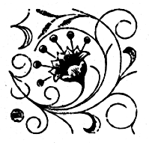
Central Minnesota Blacksmiths (CMB)
Meeting schedule Monticello, MN, (763) 295-4632. Updated schedule pending.
UMBA
Visit: www.umbaonline.org/events.htm1.

Buy, Sell, Trade or Wanted
Steel Towne Complete line of steel (by inch or lb.). N7102 SR 40 Elk Mound, WI 54739 (715) 879-5559 and a new location at 235 State Highway 35, River Falls, WI (715) 425-1138

Membership

We have three new members this month. Please welcome Arn Hanson from Osseo, Rodger Snyder from Juneau and Joe Schwenneker from Hixton. We hope to see you at our monthly meetings where we gather together to share our talents for forging. We currently have 52 members.

Up Coming Events
Badger Blacksmith 2016 Meeting Schedule

January 16 Reseburg Town Hall 9:00 to 4:30 Meeting and Demonstration
February 20 Dan Winrich 9:00 to 4:30 Meeting andDemonstration
March 19 Brad Hegge 9:00 to 4:30 Meeting and Demonstration
April 16 John Grump 9:00 to 4:30 Meeting and Demonstration
May 20-22 Spring Conference 9:00 to 4:30 Classes / Forging
June Jon Gooding 9:00 to 4:30 Meeting and Demonstration
July 30 Gary Hennig 9:00 to 4:30 Meeting and Demonstration
August 12-14 Pioneer Days 9:00 to 4:30 Open Forge
September 10 Don Hogenson 9:00 to 4:30 Meeting and Demonstration
October Jared Riesenweber 9:00 to 4:30 Meeting and Demonstration
November Jim Bloom 9:00 to 4:30 Meeting and Demonstration
December 9:00 Board Meeting
Directions to John Grump’s shop: We are located at 5890 Prill Road (Cty AA), 1 mile east of the Oakwood Mall in Eau Claire, WI. From I-94, take Exit 70 north on Highway 53 to the first Exit (85). Go right on County AA to top of hill on left. From Highway 53, take Exit 85 (AA - Golf Road) and go left to top of hill on left. Enter the first driveway at the red machine shed. See attached map.

Websites of Interest
NEW www.alloy-artifacts.org
Reference page for hand tools of the 20th Century (Brad Hegge)
http://www.spaco.org/bk.htm
Pete Stanaitis’ blacksmith section of his website which currently ranks between #10 and #14 on the Blacksmith Journal's "Top 50" list. Say hello to Pete and Sheri.
www.forums.dfoggknives.com
Blacksmith’s forum board
www.iforgeiron.com
This site has over 600 how-to tutorials. Registration is quick and free
http:/www.tunnelmillcrafts.com/ John or Carol Adams run classes at Tunnel Mill Crafts.
www.purgatoryironworks.com Free on line forum and member subscription blacksmith demonstration videos.

Tips, Techniques, and Inspiration

“To talk well and eloquently is a very great art, but that an equally great one is to know the right moment to stop”, Wolfgang Amadeus Mozart, Composer

The following articles are from the Blacksmith Journal, February,’91 & June,’98.

The Badger Blacksmiths Newsletter is written by the editor except as noted. Badger Blacksmiths, its officers, members, contributors,editors and writers specifically disclaim any responsibility, or liability for any damage, or injury as a result of the use of any information published in the newsletter or demonstrated at a meeting or conference. Every effort is made to insure the accuracy and safety of information provided, but the use by our members and readers of any information published herein or provided at meetings is solely at the user’s own risk.

