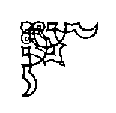
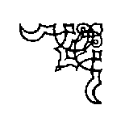
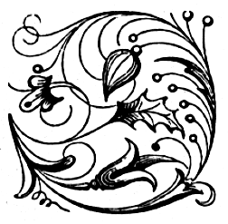
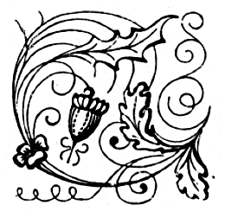
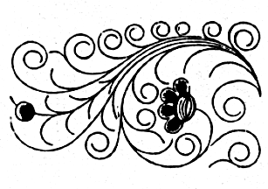
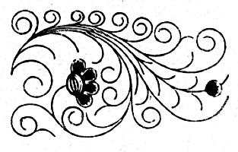
The Badger Blacksmiths
A Wisconsin Guild and ABANA Affiliate
“ We Can Forge Anything But A Check”

Volume 15, Issue 6, Newsletter Date 6/3/2016

Officers and Board
Don Hogenson President 715.265.4701
Jared Riesenweber Vice-President 715.983.5737 tudweber@hotmail.com
John Grump Secretary/Editor 715.835.0894 johngrump@att.net
Brad Hegge Treasurer 715.983.2131 heggeco@triwest.net
Ray Murray Board Member / 715.235.4882 rlmurray@pressenter.com
Director at large
Chuck Lindvig Librarian 715.832.3806 lindvig@charter.net

President’s Notes
President’s Notes June, 2016
Hello fellow blacksmiths,
Our conference is over and now it’s time to brag a bit. What good fellowship we had. I want to thank Monty B. for helping me set up Friday. He also arranged for Bob Brown to be our demonstrator. Bob was terrific.
It was so nice to see members come back on Sunday to help load everything up and clean the place up spic and span. The Village of Colfax was so good to work with on renting the grounds. I hope we consider the Fairgrounds for our next conference.
Happy Hammering,
Don Hogenson
President

NOTICE
The theme of this month’s meeting will be punching and decorative grooving. There will be plenty of forges, so bring your punches and chisels. Also bring your own chair. Hope to see you there.

Editor’s Notes

May 20, 2016 Notes
Our 14th annual Spring Conference was well attended. We had 19 families participating. The Colfax Fairgrounds is an ideal facility. There is a covered area with bleachers and ample room for the nine forges we had going at once. Just across the way is also a covered area for the meals and socializing. All in all it was a satisfying conference. Bob Brown, as all good demonstrators, make their smithing look easy. Bob did not miss a beat and with his mild demeanor, made his presentation enjoyable. We experienced how difficult it is make all your hammer blows as good as possible.
We had our usual potluck lunch on Saturday. The meeting followed and was called to order by Don Hogenson. Brad Hegge gave the Treasurer’s report. We have a balance of $4,213.13 and a raffle that netted $96. There was no old business. New business: Next month’s meeting will be at Jon Gooding’s shop. Ron Wendt suggested that when the Librarian is present that some of the material in the library should be accessible at the monthly meetings. Dave Weiss is keeping our website up to date. The website is being discussed to see if we should go with purchasing a domain name instead of the current one from Google. More to come. Noble Nygaard brought a large number of end mills for the taking. Thank you Noble. Meeting adjourned.
Show and Tell: Jim S.- brought a wine bottle and glasses holder; Don H.- Scotty dog forging; Ray M.- Copper ingots; Matt G- Copper roses on stands.

John Grump
Secretary/Editor

If you have any contributions you would like added to the newsletter, please feel free to E-Mail me at: johngrump@att.net or by mail

Treasurer’s Report
Brad Hegge reported a June 3, 2016 balance of $4, 019.47 in the treasury. Brad is preparing an audit of the Spring Conference and will present it a later date.

Other Neighborhood Smiths

Guild of Metalsmiths (GOM)
Martin Pansch, 8750 Yale Avenue, Young America, MN 55397.
www.metalsmith.org .

Lake Superior Metalsmiths (LSM)
The LSM meets the fourth Saturday of the month for potluck and meeting to follow. Contact Norm Groehler @ 715-399-8151.
Northern Minnesota Metalsmiths (NMM)
The NMM meetings are the first Monday of the month. Often, but not always, at Keith Johnson's shop in Bemidji. Contact Keith at: keith@greatriverforge.com .
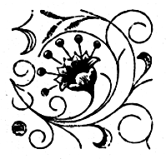
Central Minnesota Blacksmiths (CMB)
Meeting schedule Monticello, MN, (763) 295-4632. Updated schedule pending.
UMBA
Visit: www.umbaonline.org/events.htm1.

Buy, Sell, Trade or Wanted
Steel Towne Complete line of steel (by inch or lb.). N7102 SR 40 Elk Mound, WI 54739 (715) 879-5559 and a new location at 235 State Highway 35, River Falls, WI (715) 425-1138

Membership

There are no new members this month. We currently have 53 members.

Up Coming Events
Badger Blacksmith 2016 Meeting Schedule

January 16 Reseburg Town Hall 9:00 to 4:30 Meeting and Demonstration
February 20 Dan Winrich 9:00 to 4:30 Meeting andDemonstration
March 19 Brad Hegge 9:00 to 4:30 Meeting and Demonstration
April 16 John Grump 9:00 to 4:30 Meeting and Demonstration
May 20-22 Spring Conference 9:00 to 4:30 Classes / Forging
June 11 Jon Gooding 9:00 to 4:30 Meeting and Demonstration
July 30 Gary Hennig 9:00 to 4:30 Meeting and Demonstration
August 12-14 Pioneer Days 9:00 to 4:30 Open Forge
September 10 Don Hogenson 9:00 to 4:30 Meeting and Demonstration
October Jared Riesenweber 9:00 to 4:30 Meeting and Demonstration
November Jim Bloom 9:00 to 4:30 Meeting and Demonstration
December 9:00 Board Meeting
Information and directions for the June meeting
The June meeting will be at Jon Gooding’s shop. His shop is located at 2428 10th Avenue, southeast of Baldwin. From the west take I-94 to Exit 19 (Baldwin). Go south to CTH N. Left on N to CTH BB. Right on CTH BB to 10th Avenue. Left on 10th to first place on left. From the east take Exit 24, Highway B (Woodville). Go south on CTH B to 10th Avenue. Go right to 2428 10th Avenue on right.

Websites of Interest
NEW www.alloy-artifacts.org
Reference page for hand tools of the 20th Century (Brad Hegge)
http://www.spaco.org/bk.htm
Pete Stanaitis’ blacksmith section of his website which currently ranks between #10 and #14 on the Blacksmith Journal's "Top 50" list. Say hello to Pete and Sheri.
www.forums.dfoggknives.com
Blacksmith’s forum board
www.iforgeiron.com
This site has over 600 how-to tutorials. Registration is quick and free
http:/www.tunnelmillcrafts.com/ John or Carol Adams run classes at Tunnel Mill Crafts.
www.purgatoryironworks.com Free on line forum and member subscription blacksmith demonstration videos.

Tips, Techniques, and Inspiration

“The problem is not that there are problems. The problem is expecting otherwise and thinking that having problems is a problem”, Theodore Issac Rubin, Psychiatrist.

The following article is from the Blacksmith Journal, August 2003.

The Badger Blacksmiths Newsletter is written by the editor except as noted. Badger Blacksmiths, its officers, members, contributors,editors and writers specifically disclaim any responsibility, or liability for any damage, or injury as a result of the use of any information published in the newsletter or demonstrated at a meeting or conference. Every effort is made to insure the accuracy and safety of information provided, but the use by our members and readers of any information published herein or provided at meetings is solely at the user’s own risk.

