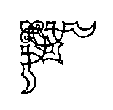
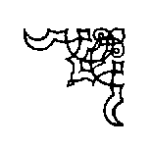
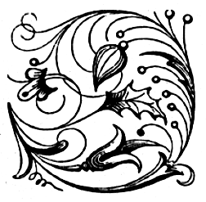
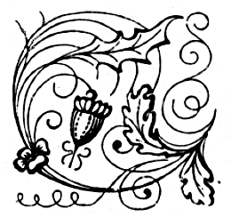
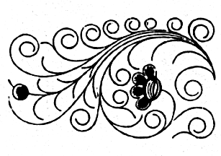
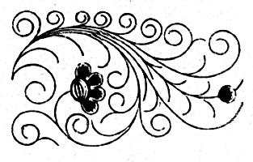
The Badger Blacksmiths
A Wisconsin Guild and ABANA Affiliate
“ We Can Forge Anything But A Check”

Volume 15, Issue 2, Newsletter Date 2/4/2016

Officers and Board
Jared Riesenweber President 715.983.5637 tudweber@hotmail.com
Dion Grethen Vice-President 715.651.3398 diongrethen@gmail.com
John Grump Secretary/Editor 715.835.0894 johngrump@att.net
Brad Hegge Treasurer 715.983.2131 heggeco@triwest.net
Ray Murray Board Member / 715.235.4882 rlmurray@pressenter.com
Director at large
Chuck Lindvig Librarian 715.832.3806 lindvig@charter.net

President’s Notes

Hello from Pigeon Falls. Hope everyone is keeping warm and doing well. I’ve missed out on more meetings than I’d like, am working many extra hours and a number of difficulties. I did manage to get in some forging making new projects for Christmas presents, in my first year with a heated shop. It sure makes things easier. I spoke with Brad to catch up a bit on the last few months. We have a great plan for the coming year of meetings and a new location and date for the conference and as always a huge potential to learn and make great things. Hope to see you at Dan’s meeting this month. Bring your ideas and suggestions of what you want to see and do. Thanks.

Jared Riesenweber
President
ATTENTION
I am storing the club’s coal. If you need any coal give me a call, 715-835-0894, or an Email, johngrump@att.net, and I will bring it to the next meeting.
2016 Dues were due in January. Send or give Brad Hegge your dues so that we can continue to supply you with the newsletter. His address is W12564 State Road 121, Osseo, WI 54758. Thank you.
An additional thank you goes to Pete Stanaitis, who is lending me his copies of the Blacksmith Journal for use in the newsletters.

Editor’s Notes
January 16, 2016 Notes: I was on vacation and unable to attend the January meeting. Don Hogenson was kind enough to take notes from the meeting. Thank you, Don. The January meeting was held at the Reseburg Town Hall. Brad Hegge chaired the meeting and called it to order. Brad also submitted the Treasure’s report, which was approved. Don Hogenson gave an update on the Spring Conference which will be held May 20 -22 at the Colfax Fair Grounds. Bob Brown will be the demonstrator on the 21st. More details will follow in upcoming newsletters. Brad Hegge has been contacted by a company that uses Titanium in forgings. More info later as to a possible demonstration of their techniques.
The meeting schedule for February and March have been finalized. The February meeting will be at Dan Winrich’s shop on the 20th and the March meeting will be at Brad Hegge’s shop on the 19th. Please mark your calendars and see the Up-Coming Events calendar.
There was a discussion on the price of coal to members. The agreed-on price will be $8.00 per bucket. Contact me if you need coal. Meeting adjourned.
Show and Tell – Jim S. showed a beautifully decorated shelf bracket and a knife with a copper wrapped handle; Matt G. showed some nice roses.
In the workshop, Dan W. demonstrated a quick miner’s lamp and Don H. and Brad H. made coat hooks. Hope to see you at the February meeting.
John Grump
Secretary/Editor

Treasurer’s Report
Brad Hegge reported a February 3, 2016 balance of $4,022.99.

Other Neighborhood Smiths

Guild of Metalsmiths (GOM)
Martin Pansch, 8750 Yale Avenue, Young America, MN 55397.
www.metalsmith.org .
Lake Superior Metalsmiths (LSM)
The LSM meets the fourth Saturday of the month for potluck and meeting to follow. Contact Norm Groehler @ 715-399-8151.
Northern Minnesota Metalsmiths (NMM)
The NMM meetings are the first Monday of the month. Often, but not always, at Keith Johnson's shop in Bemidji. Contact Keith at: keith@greatriverforge.com .
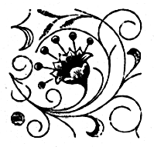
Central Minnesota Blacksmiths (CMB)
Meeting schedule Monticello, MN, (763) 295-4632. Updated schedule pending.
UMBA
Visit: www.umbaonline.org/events.htm1.

Buy, Sell, Trade or Wanted
Steel Towne Complete line of steel (by inch or lb.). N7102 SR 40 Elk Mound, WI 54739 (715) 879-5559 and a new location at 235 State Highway 35, River Falls, WI (715) 425-1138
Membership

There is one new member this month. He is Caleb Welle from Bloomer, WI. Welcome Caleb and we hope to see you at our monthly meetings, where we practice our blacksmithing skills through demonstration and hammering. We currently have 28 paid members.

Up-Coming Events
Badger Blacksmith 2015 Meeting Schedule

January 16 Reseburg Town Hall 9:00 to 4:30 Meeting and Demonstration
February 20 Dan Winrich 9:00 to 4:30 Meeting and Demonstration
March 19 Brad Hegge 9:00 to 4:30 Meeting and Demonstration
April 16 John Grump 9:00 to 4:30 Meeting and Demonstration
May 20-22 Spring Conference 9:00 to 4:30 Classes / Forging
June Jon Gooding 9:00 to 4:30 Meeting and Demonstration
July 30 Gary Hennig 9:00 to 4:30 Meeting and Demonstration
August 12-14 Pioneer Days 9:00 to 4:30 Open Forge
September 10 Don Hoganson 9:00 to 4:30 Meeting and Demonstration
October Jared Riesenweber 9:00 to 4:30 Meeting and Demonstration
November Jim Bloom 9:00 to 4:30 Meeting and Demonstration
December 9:00 Board Meeting

Information and Directions for February’s meeting. The February 20th meeting will be at Dan Winrich’s shop. Dan’s shop is located at 7460 Schumacher Road, Fall Creek, WI. Dan will be demonstrating making hooks out of railroad spikes. You will be able to join in and make your own hook. Dan will supply the spikes. Don Hogenson will also be demonstrating his hot shear. Bring your safety equipment and your tools and join in the hammering.
See attached map.

Websites of Interest
http://www.spaco.org/bk.htm
Pete Stanaitis has a blacksmith section of his website. Say hello to Pete and Sheri.
www.forums.dfoggknives.com
Blacksmith’s forum board.
www.iforgeiron.com
This site has over 600 how-to tutorials. Registration is quick and free.
http:/www.tunnelmillcrafts.com/ John or Carol Adams run classes at Tunnel Mill Crafts.
www.purgatoryironworks.com Free on-line forum and member subscription blacksmith demonstration videos.
www.badgerblacksmith.com Our website, which is the work of Jared Riesenweber. Any comments or suggestions should be directed to Jared.
www.abana.org ABANA is the Artist Blacksmith Association of North America. We are an affiliate of ABANA.

Upcoming Blacksmithing Events

2016 ABANA Conference
July 13-16 Salt Lake City, Utah
Register at www.abana.org

2016 Little Giant Rebuilding Seminar – March 11-13
“Make your Little Giant Power Hammer Work Harder Than Ever”
Information and Registration at 402-873-6605

2016 BAM Conference
April 28 – May 1
25th Anniversary Ozark Blacksmith Conference – Sedalia, Missouri
Register at www.bamsite.org

Tips, Techniques, and Inspiration

“Don’t compare yourself with anyone in this world. If you do so, you are insulting yourself”, Bill Gates, businessman and philanthropist.

The Badger Blacksmiths Newsletter is written by the editor except as noted. Badger Blacksmiths, its officers, members, contributors, editors and writers specifically disclaim any responsibility, or liability for any damage, or injury as a result of the use of any information published in the newsletter or demonstrated at a meeting or conference. Every effort is made to ensure the accuracy and safety of information provided, but the use by our members and readers of any information published herein or provided at meetings is solely at the user’s own risk.
The following are from “The Blacksmith’s Journal” April, 1995 & September, 2001.

The “Potluck” or “How To Allay the Fear of Coming To Your First Blacksmith Club Meeting” by Pete Stanaitis

I wonder how many of our newer members avoid coming to our monthly meetings because they don’t know how to deal with the “Potluck”.

Or, I wonder if some folks came to one meeting without bringing any food and then wondered where it all came from or even felt guilty for not bringing anything, but didn’t know what the protocol was.

Well, if you fit any of the above categories, this little article is for you.

Webster’s defines it as follows:
Potluck n. Whatever the family meal happens to be. As in “Will you take potluck with us?”

The Club’s “Potluck” is simply a way to provide a varied meal without having to make a whole bunch of entrées and desserts all by yourself. And it gets the job done without having to charge for a meal. It also is self-limiting in that we never really have to worry about having too much or too little food.

When a meeting is announced as a “Potluck”, it simply means that each member (or member family) is supposed to bring some food or drink, to be shared with the rest of the attendees. Unless announced, every Badger Blacksmith meeting is a potluck. Some people tend to bring main dishes, some usually bring salads, some bring desserts, etc. It is amazing to me that we have never had a “failed” potluck. There always seems to be a good selection of foods from which to choose.

Some say that you should bring about 1½ times the amount of food that you’d need to feed everyone in your party. And you take your own leftovers (if there are any) home with you.

We usually bring a Crockpot full of a spaghetti casserole or something like that. But if we don’t have time to cook, we can always stop at Kentucky Fried Chicken and pick up a container of regular chicken. Some people like to bake cookies while others bring a couple of bags of potato chips. Even a twelve pack of soft drinks is welcomed.

The Club supplies coffee and some soft drinks, drinking cups, the dinnerware (plastic), napkins, serving spoons, and tables and chairs.

So, now you that have the background of this tradition, you can come to the meetings and participate in the eating with confidence!

Christmas Tree
By Steve Anderson, a MABA member

Stock-
Large Tree: 1/4ʺ round x 60ʺ
Small Tree: 1/4ʺ round x 40ʺ

Taper down leaving 3/4ʺ on end.

Place in vise and upset the end to about 3/8ʺ.

Bend the upset end to 90º, then wind 1/4ʺ round stock
into a tight coil, stopping about 4ʺ from the end.

Heat the entire coil to uniform orange and clamp the
end in a vise while supporting opposite side of the
largest coil with tongs. Pull upwards on the center with
a vise grips. As the first coil separates, use the tongs
and a flat bit screw driver to support top of the coil as
the next one pulls up. Continue to support , moving up
as each coil separates. When the rings do not readily
separate, use a flat bit screw driver to coax them apart.

Taper the last 3ʺ of the tail end to a two sided taper.

