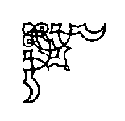
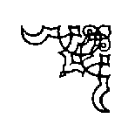

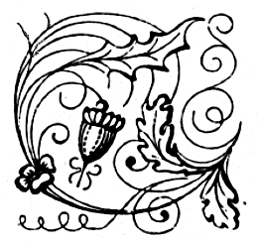
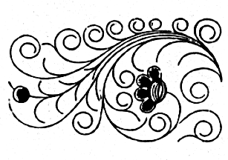
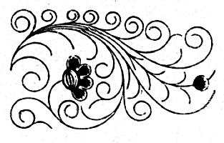
The Badger Blacksmiths
A Wisconsin Guild and ABANA Affiliate
“ We Can Forge Anything But A Check”

Volume 14, Issue 9, Newsletter Date 9/1/2015

Officers and Board
Jared Riesenweber President 715.983.5637 tudweber@hotmail.com
Dion Grethen Vice-President 715.651.3398 diongrethen@gmail.com
John Grump Secretary/Editor 715.835.0894 johngrump@att.net
Brad Hegge Treasurer 715.983.2131 heggeco@triwest.net
Ray Murray Board Member / 715.235.4882
Director at large
Chuck Lindvig Librarian 715.832.3806 lindvig@charter.net

President’s Notes

NO PRESIDENT’S NOTES THIS MONTH

Editor’s Notes
AUGUST 7, 2015 Notes
Pioneer Days were August 7,8 & 9. I attended on Friday and we had 5 smiths forging. We made and sold a fair number of items. It is always a good time to catch up and learn from each other.
Next month’s meeting is at Lee Waldhart’s shop. Lee has a wonderful shop, which he expanded this year. He constructed a series of carrousels to house his steel stockpile. Lee will also have his CNC plasma cutter operating. He constructed a mezzanine out of two spiral staircases he made for a client, who backed out of the commission. The meeting will include a potluck, at which, Lee will roast a pork loin on his smoker/cooker to add to the lunch. If anyone has any sweet corn left, bring it and Lee will prepare it on the cooker. I always look forward to Lee’s meetings. There is always something new and interesting. Hope to see you there.
I have two remaining mini-swage blocks. They are $105 each. If interested, call, and I will bring them to the meeting.

John Grump
Secretary/Editor
Treasurer’s Report

Brad Hegge reported a September 1, 2015 balance of $4,029.69.

Other Neighborhood Smiths
Guild of Metalsmiths (GOM)
Martin Pansch, 8750 Yale Avenue, Young America, MN 55397.
www.metalsmith.org .
Lake Superior Metalsmiths (LSM)
The LSM meets the fourth Saturday of the month for potluck and meeting to follow. Contact Norm Groehler @ 715-399-8151.
Northern Minnesota Metalsmiths (NMM)
The NMM meetings are the first Monday of the month. Often, but not always, at Keith Johnson's shop in Bemidji. Contact Keith at: keith@greatriverforge.com .
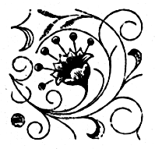
Central Minnesota Blacksmiths (CMB)
Meeting schedule Monticello, MN, (763) 295-4632. Updated schedule pending.
UMBA
Visit: www.umbaonline.org/events.htm1.

Buy, Sell, Trade or Wanted
Steel Towne Complete line of steel (by inch or lb.). N7102 SR 40 Elk Mound, WI 54739 (715) 879-5559 and a new location at 235 State Highway 35, River Falls, WI (715) 425-1138
Membership

There is one new member this month. Please welcome Wes Erickson. Wes is from Durand. We currently have 57 members.

Up-Coming Events
Badger Blacksmith 2015 Meeting Schedule

January 17 Reseburg Town Hall 9:00 to 4:30 Meeting and Demonstration
February 21 Brad Hegge 9:00 to 4:30 Meeting and Demonstration
March 14 Dan Winrich 9:00 to 4:30 Meeting and Demonstration
April 18 Minnesota RR 9:00 to 4:30 Meeting, Tour and
Museum Demonstration
May 22-24 Spring Conference 9:00 to 4:30 Classes / Forging
June 20 John Grump 9:00 to 4:30 Meeting and Demonstration
July 18 Gary Hennig 9:00 to 4:30 Meeting and Demonstration
August 7-9 Pioneer Days 9:00 to 4:30 Open Forge
September 12 Lee Waldhart 9:00 to 4:30 Meeting and Demonstration
October 17 Monte Bygd 9:00 to 4:30 Meeting and Demonstration
November 14 Jared Riesenweber 9:00 to 4:30 Meeting and Demonstration
December Board Meeting TBA

Information and Directions for September’smeeting. The September 12th meeting will be at Lee Waldhart’s shop. See Editor’s Notes for details. Lee’s shop is located at W3226 Stetson Avenue, Stetsonville, WI. Take Highway 29 to State Highway 13 in Abbotsford. Go North on Highway 13 for 8 miles to Stetson Avenue. Go East or right on Stetson Avenue to W3226 on left. Hope to see you there. See attached map.

Websites of Interest
http://www.spaco.org/bk.htm
Pete Stanaitis has a blacksmith section of his website. Say hello to Pete and Sheri.
www.forums.dfoggknives.com
Blacksmith’s forum board.
www.iforgeiron.com
This site has over 600 how-to tutorials. Registration is quick and free.
http:/www.tunnelmillcrafts.com/ John or Carol Adams run classes at Tunnel Mill Crafts.
www.purgatoryironworks.com Free on-line forum and member subscription blacksmith demonstration videos.
www.badgerblacksmith.com Our website, which is the work of Jared Riesenweber. Any comments or suggestions should be directed to Jared.
www.abana.org ABANA is the Artist Blacksmith Association of North America. We are an affiliate of ABANA.

Tips, Techniques, and Inspiration

“Talent hits a target no one else can hit; genius hits a target no one else can see.” Arthur Schopenhaver, German philosopher.

The Badger Blacksmiths Newsletter is written by the editor except as noted. Badger Blacksmiths, its officers, members, contributors, editors and writers specifically disclaim any responsibility, or liability for any damage, or injury as a result of the use of any information published in the newsletter or demonstrated at a meeting or conference. Every effort is made to ensure the accuracy and safety of information provided, but the use by our members and readers of any information published herein or provided at meetings is solely at the user’s own risk.

The following are from “The Hammer’s Blow”, 2002, 2003 and 2009.

The “Potluck” or “How To Allay the Fear of Coming To Your First Blacksmith Club Meeting” by Pete Stanaitis

I wonder how many of our newer members avoid coming to our monthly meetings because they don’t know how to deal with the “Potluck”.

Or, I wonder if some folks came to one meeting without bringing any food and then wondered where it all came from or even felt guilty for not bringing anything, but didn’t know what the protocol was.

Well, if you fit any of the above categories, this little article is for you.

Webster’s defines it as follows:
Potluck n. Whatever the family meal happens to be. As in “Will you take potluck with us?”

The Club’s “Potluck” is simply a way to provide a varied meal without having to make a whole bunch of entrées and desserts all by yourself. And it gets the job done without having to charge for a meal. It also is self-limiting in that we never really have to worry about having too much or too little food.

When a meeting is announced as a “Potluck”, it simply means that each member (or member family) is supposed to bring some food or drink, to be shared with the rest of the attendees. Unless announced, every Badger Blacksmith meeting is a potluck. Some people tend to bring main dishes, some usually bring salads, some bring desserts, etc. It is amazing to me that we have never had a “failed” potluck. There always seems to be a good selection of foods from which to choose.

Some say that you should bring about 1½ times the amount of food that you’d need to feed everyone in your party. And you take your own leftovers (if there are any) home with you.

We usually bring a Crockpot full of a spaghetti casserole or something like that. But if we don’t have time to cook, we can always stop at Kentucky Fried Chicken and pick up a container of regular chicken. Some people like to bake cookies while others bring a couple of bags of potato chips. Even a twelve pack of soft drinks is welcomed.

The Club supplies coffee and some soft drinks, drinking cups, the dinnerware (plastic), napkins, serving spoons, and tables and chairs.

So, now you that have the background of this tradition, you can come to the meetings and participate in the eating with confidence!

Christmas Tree
By Steve Anderson, a MABA member

Stock-
Large Tree: 1/4ʺ round x 60ʺ
Small Tree: 1/4ʺ round x 40ʺ

Taper down leaving 3/4ʺ on end.

Place in vise and upset the end to about 3/8ʺ.

Bend the upset end to 90º, then wind 1/4ʺ round stock
into a tight coil, stopping about 4ʺ from the end.

Heat the entire coil to uniform orange and clamp the
end in a vise while supporting opposite side of the
largest coil with tongs. Pull upwards on the center with
a vise grips. As the first coil separates, use the tongs
and a flat bit screw driver to support top of the coil as
the next one pulls up. Continue to support , moving up
as each coil separates. When the rings do not readily
separate, use a flat bit screw driver to coax them apart.

Taper the last 3ʺ of the tail end to a two sided taper.

