How to make a ZVS induction Heater System
Date created: December 31, 2020

Scope of this article:
This article is aimed at making your own 1000 watt ZVS induction heating system from off the shelf components that can be purchased online.
It assumes that the reader has some basic knowledge of electronics.
It also assumes that you will buy an assembled and tested "12 to 48 Volt DC 1000 Watt ZVS Induction Heater" from one of the many sellers around the world.
These heaters almost always come with one work coil. Some of them also have a 12 volt DC cooling fan and some way (usually a buck converter borrowing power from the main power supply) to power it.
A serious caveat to assembling your own 1000 watt unit: 48 volt 20 to 25 amp DC power supplies are hard to find and are not cheap. Expect to pay almost as much for one of them as you'd have to pay (between USD$80 and USD$100) for the (used) 48 volt 50 or 60 amp server power supply that is often used to power the 2500 Watt units!
So you may be better off to buy a 2500 watt induction heater KIT instead. Most of the instructions below relate to the 2500 watt units, too.

Safety: The input to the power supply is "Mains" power. Use care when making these connections to avoid shock of even death.
Although the power supply's output is only 48 volts DC, the circuit on the board increases this voltage to as much as about pi (3.14) times the input to about 150 volts which can be lethal!!!
Also, the work coil and other components are subject to heating, so avoid touching any parts of the system while it is in operation.

Before you start buying components, you need to decide and actually write down your reasons for building one.
This will help you focus on exactly what components you will need to get a basic system up and running.

The basic steps:
1. Identify your needs, google around for related videos and websites.
-Do you simply want to experiment with Induction heating?
-Do you have a specific need in mind? Like melting nonferrous metals? Or like heating pieces of steel to make them easy to bend?
-Will roughly 1000 watts of heating power be enough to do what you want to do? That amount of power (a little less than 3000 BTU's, net, to the work coil) is less than the heating power of many "hardware store" propane torches.

2. Order your components.
You need to buy:
- The basic induction heater with work coil,
-48 volt DC power supply that can deliver at least 20 amps (for the 1000 watt unit).
Note: some of these power supplies work on either 120VAC or 220VAC.
But some of the higher current power supplies REQUIRE 220VAC to deliver full power.
-12 volt DC Cooling fan for the circuit board (if the board you buy does not have one),
- 60 volt to 12 volt DC Buck Converter to power the fan (if the board you buy does not have one)
- 20 Amp, 50 volt or more, DC rated SPST switch or equivalent circuit breaker to use as a DC power switch,
- Small water pump that can handle 150°F water, with appropriate power supply,
-Water reservoir or radiator. I use fan cooled radiators of about 2 quart capacity.
If you plan to use a simple water container, I'd suggest that it hold at least 2 gallons of water if you plan to run your system for more than 5 or 10 minutes at a time.
-Flexible vinyl tubing to connect the pump to the work coil and to a cool water reservoir
- 0 to 50 amp analog current meter with a matching shunt. Although not absolutely necessary, I strongly suggest it. This is needed to keep you from exceeding the maximum current that the heater draws from the power supply. It is also a great aid in monitoring your heating rate.
-Ceramic or Fiberglass insulating sleeving to cover the work coil. Also highly recommended. Its main purpose is to protect the copper work coil's turns from being short circuited when placing workpieces within it. A secondary benefit is that the insulation will reflect some of the workpiece's heat back toward itself, increasing the efficiency of the system.
- You will also need red and black insulated 12 gauge and 18 gauge (solid or stranded) wire to connect the system parts together.
These components are all available from Ebay, Amazon, Aliexpress and Banggood. For most of the 1000 watt induction heaters currently for sale, you will have to buy all these parts separately and then assemble the system.

As of Dec 30, 2020, Here's one of the most complete Kits for the 1000 watt unit that I have seen:
https://www.ebay.com/itm/ZVS-Induction-Heating-Board-1000W-Flyback-Driver-Tesla-Coil-pump-Power-supply/183493513753?
The cost is about USD$156, with free shipping.

Here's an easier (and not much more expensive) solution to getting most of the components at one place:
For the larger, 1800 watt and 2500 watt units, there are many sellers who offer complete "kits" or "combination packages" that include almost everything that I have mentioned except for the cooling reservior and the current meter.
Here is one example of such a "kit": Go to Banggood.com and enter this search criteria: Geekcreit® 2500W 48V 50A ZVS Induction Heating Module High Frequency Heating Machine Melted Metal Coil With Power Supply Full Kit. This kit is about USD$185.00.

3. Decide on some way to mount the system components. There are many videos and webpages that give examples of how others have done this.
-If you decide to put all the components in some sort of box, make sure that there is plenty of free air flow.

4. Assemble the components on your chosen medium.

5. Wire the system.
Here is a Basic Wiring/Plumbing diagram:
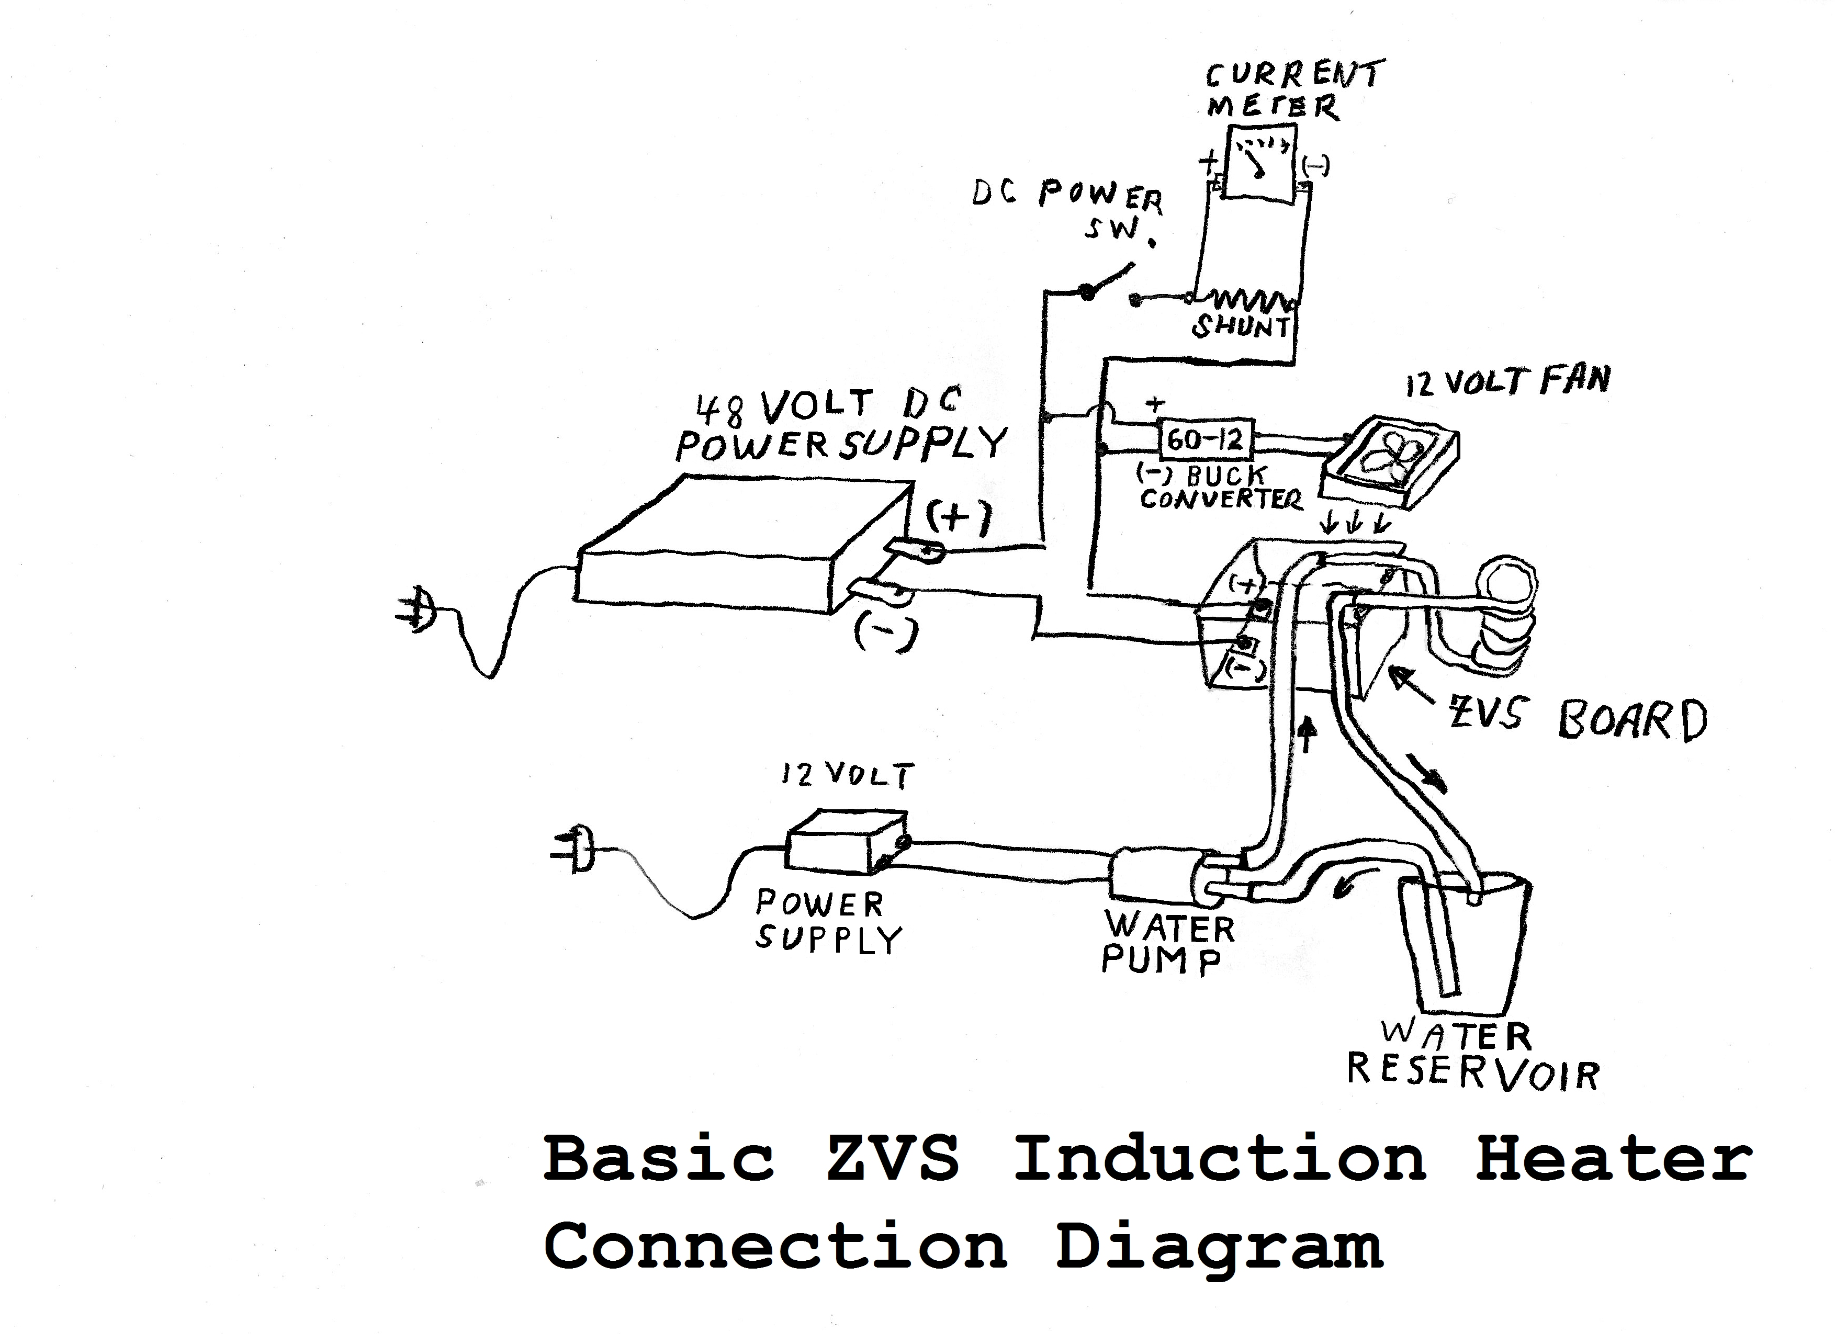
Use wire of at least 12 gauge for the power wiring from the 48 volt power supply to the DC switch or circuit breaker, the current shunt and the board. You may use 18 or even 20 gauge wire for the buck converter, for the fan, for the water pump and for the connections between the current shunt and the analog meter.
I ALWAYS use red wire for the positive leads and black wire for the negative leads.

6. Plumb the work coil cooling system. The work coil MUST be water cooled. If the work coil is not water cooled, the heat will transfer to the ZVS board and to the capacitors on it. This can cause system failures. Some people don’t cool their work coils and they may “get away with it” for a while when only using a short heating cycle, but don’t be one of them!
Attach the work coil to the board and connect water cooling tubing to the work coil. Make certain that the OUTPUT of the water pump connects to the LOW (bottom) side of the work coil. This is necessary so the water pushes any air or steam UPWARDS and out of the coil toward the cooling reservoir. If you get this wrong, you can get pockets of steam that can blow the tubing off and the liquid water won’t be able to cool the coil as well.

7. Test the system.
A. Apply power to the cooling pump and verify that water is circulating freely through the work coil. Check for leaks and correct them before continuing.
A2. Apply power to the cooling fan and verify that it is pushing air DOWN from the top toward the Mosfets and capacitors.
B. With the DC switch OFF, apply mains power to the power supply.
Note: Many power supplies don’t come up to full output until several seconds have passed after applying mains power. If you don’t have the DC switch off during that time, you will probably burn out the ZVS Induction Heater Board.
Measure the DC output of the power supply after it has been on for about 10 seconds. You should read somewhere between about 47 and 52 Volts DC.
C. While watching the current meter, turn the DC switch "ON". You should see a current of between about 4 and 8 amperes flowing. This is the normal "Idle Current" for the system.
If the current flow is not within this range, turn the switch off immediately and troubleshoot the system.
Here is my troubleshooting guide:
https://spaco.org/Blacksmithing/ZVSInductionHeater/1000Watt12to48VoltZVSInductionHeaterTroubleshootingGuide.htm
D. Once the Idle current is within range, insert a 1/2" round or square piece of steel rod slowly into the work coil, being careful not to let the steel touch the copper work coil (if you have not insulated it). The current should rise above the idle current range. The deeper you push it into the work coil, the higher the current should go. Do not allow the current to exceed about 20 amperes.

8. Begin using the system. Once you system passes Test 7D you are ready to begin using it for your intended purpose.
I strongly suggest that you study the material here:
https://spaco.org/Blacksmithing/ZVSInductionHeater/1000WattZVSInductionHeaterNotes.htm
as you plan your next move.
-------------------------------------------------------------------------------------------------------------------------------
If you go to my induction heating playlist, https://www.youtube.com/playlist?list=PLVxWen9M87dBhvInCQ-3pELWdxCM3XH4I and watch the videos there, you can get many details on how I build and control and utilize these small induction heating systems.

