ZVS High Frequency Induction Heating 1800W High Frequency Machine Without Tap ZVS
Created: Dec 5, 2018, last revised: Dec 25, 2018

I received it on Monday, November 26, 2018
It's all there, including a circuit breaker that I didn't know was coming. It's to be used between the power supply's output and the heater, to turn the heater on and off and to pop if current goes too high.

Maybe I should break down and buy a DC clamp-on ammeter.
I have ordered a second analog ammeter/shunt system just for this project.
The copper melting guy (see video link below) has a nice LCD meter, but I can't see exactly what it reads or how it is connected.

1500W heating 45*80 large stone pot melting copper video (copy link to browser to watch):

http://v.youku.com/v_show/id_XMzAzOTU5NjIxMg==.html?spm=a2h3j.8428770.3416059.1

"In this test, the maximum power is close to 1600W, and the maximum current is 35A. This product is available at
Under the condition of good heat dissipation, the utility model can work continuously for hours."

Here's what I bought:
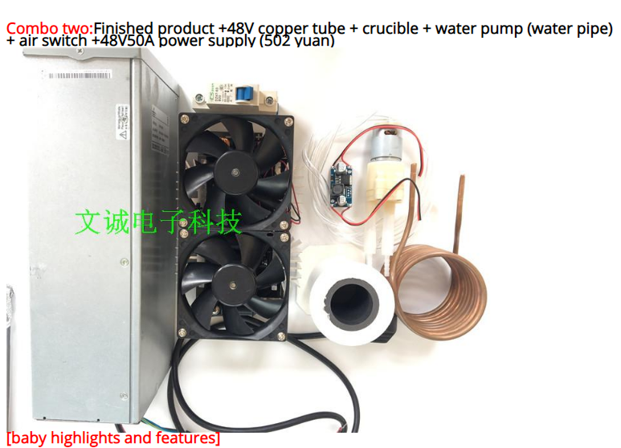
--------------------------------------------------------------------------------------------------------------------------------------------

Regarding power for the fan and pump:
[5]The package comes with heating ring diameter is 60mm, the design of voltage 36V, if the above 40V voltage power supply used to use heating coil diameter of more than 70mm, the pump 12V DC power supply, please use a separate power supply voltage regulator module to avoid damage of fan and water pump.
If I were to rewrite this paragraph:
"Combo Kit Two comes with a work coil whose inner diameter is 60mm. The heater's design voltage is 36 volts DC input. But, if you apply more than 40 volts to the heater, and use a work coil whose inner diameter is greater than 70mm, the regulator for the pump and fans will be overstressed and may fail. So, use a separate power supply for the pump."
I think I understand the general idea of this paragraph, except for the part about the 70mm work coil. For now, I will assume that they are saying that larger diameter work coils will somehow supply higher voltages to the regulator's input?

I think this means that the little voltage regulator that comes with the system can't handle anything beyond about 36 volts.
Maybe I need a separate power supply for the peripherals on this heater, too.
***I need to see if the fans run from that little voltage regulator or if it's just the pump.
I should also measure the current that both the fans and the pump take.

***New Note on Dec 18:
I just realized that the vendor sells a unit with a "36 volt coil" and one with a "48 volt coil". I wonder if these two units have some different circuitry for the fans/pump regulator.

[3] board do not empty, otherwise it will send a very high frequency noise, and then MOS tube (Mosfet) will burn out

Don't run the board without a coil connected to it.

----------------------------------------------------------------------------------
Power Supply:
Even though it appears to have a 110 volt plug, I think it is designed for 220.
I think I need to open it up to check for loose components before I try to power it up. I guess I need to do that anyway just to figure out which jacks connect to what.

Dec 16, 2018 update:
Power Supply:
I found the manual for it!!
It can run on anything from about 85 volts ac to about 270 volts ac. But It only delivers about 1500 watts at 125vac. However, it delivers its full 2900 watts at 176 vac and higher, up to 270 vac.
This means, of course, that to get the power up to 1800 to 2000 watts, one needs to plug it in to a 220/240 vac circuit.

Power Supply Output/managing current to ZVS driver:
I do have a 50 amp DC analog meter with a 75 millivolt shunt on order, to insert into the DC output line of the power supply. An analog meter is better than a digital meter in my mind since I can see the rate of change more easily as I watch the meter out of the corner of my eye while also watching the coil area as I insert the work, to make certain that I am not exceeding current limits for the device.

------------------------------
Dec 19, 2018 Update:

Sources for this "1800 Watt ZVS induction heater"
This morning, I went looking for all the sources I could find for this machine.
So far, I see them for sale on:
Aliexpress (where I bought my "Combo two")
Banggood. offers combo two
Ebay No combo two, but has a combo with all but power supply
Cozzoo No combo two, but has a combo with all but power supply
Amazon No combo two, but has a combo with all but power supply
Walmart No combo two, but has a combo with all but power supply
dhgate (full kit, but VERY high price)
---Later in the day I found several other vendors. Most sell only the ZVS board plus coil.

Note: Some are spec'd as 1800 watt and some are spec'd as 2500 watt.
Dec. 25, 2018 Update:
There IS a significant difference between them. The 2500 watt model seems to have 3 Mosfets on each side of the resonant circuit instead of just 2 on each side for the 1800 watt version. The 2500 watt version PC board is also larger and has larger fans. (the 1800 watt unit has 90mm fans, whereas the 2500 watt unit has 120mm fans. Mads Barnkob,
(https://highvoltageforum.net/index.php?board=2.0)
very politely pointed this out to me just recently.

About Fan/Pump power
Some have the fan power supply built into the board.
Some have it separate on a small pcb that plugs into a connector on the main board.
I'm guessing that, if the power supply is built into the main pcb, it may not also handle the water pump that came with my "Combo 2" 1800 watt unit.

The description of all of these offerings came from the very early Aliexpress vendor's ad, I think.
In many cases, the other vendors just copied the description, but in some cases they truncated
it.
In a couple of cases, somebody did take the time to add a comment or two.
One funny thing I found is that most of them kept the Aliexpress sentence that described a twenty minute crucible/copper-melting demo video but eliminated the link to it making that sentence totally unintelligible. Obviously the vendors doing the copying are not paying any attention to what they are presenting.

About coil size/ power output
Fact: In general, the closer the workpiece fits the ID of the work coil, the more power will be transferred to the work.

I see that some of vendors use a (roughly) 60 mm diameter work coil and some use a 70 mm diameter coil.
As we can see if we DO read the Chinglish description carefully, they are worried that users will put too much "work material" into the work coil and cause it draw too much current.
I currently guess that if they send us a larger (70mm vs the 60mm coil that my unit came with) coil, they feel that the work will be farther away from it and consequently draw less current. For a fixed size of workpiece (such as the graphite crucible that comes with many of these units, that is true.
You can see me discuss this here:
https://www.youtube.com/watch?v=DLKbQ7NkYkk&t=54s
starting at 0:26 seconds when I talk about the amount of current drawn by two different diameters of graphite crucibles.

